Apache NiFi: Beginner Exercises Guide

Objective:
Learn to build basic dataflows using Apache NiFi processors, understand core concepts, and develop practical data
Prerequisites: NiFi installed and running locally (default UI: https://localhost:8443/nifi or http://localhost:8080/nifi depending on your version), and basic familiarity with drag-and-drop in the canvas.

Exercise 1: Hello Flow
Goal: Understand FlowFiles, connections, and the Start/Stop lifecycle.
Processors used: GenerateFlowFile, LogAttribute

Steps
- Drag a processor onto the canvas. Search for GenerateFlowFile, select it, click Add.
- Double-click the processor to configure it. On the Properties tab, set:
  - File Size: 0B
  - Leave other defaults.
- Drag a second processor onto the canvas: LogAttribute. Add it.
- Hover over GenerateFlowFile until an arrow appears, drag it onto LogAttribute to create a connection. In the dialog, check the success relationship, click Add.
- Right-click GenerateFlowFile → Configure → Scheduling tab → set Run Schedule to 10 sec (so it doesn't flood your log).
- Select both processors (click, then shift-click) → right-click → Start.
- Right-click LogAttribute → View Data Provenance. You should see events listed as FlowFiles pass through.
- Open the NiFi app log (logs/nifi-app.log in your install directory) and confirm you see logged attribute output.
- Stop both processors when done (select → right-click → Stop).
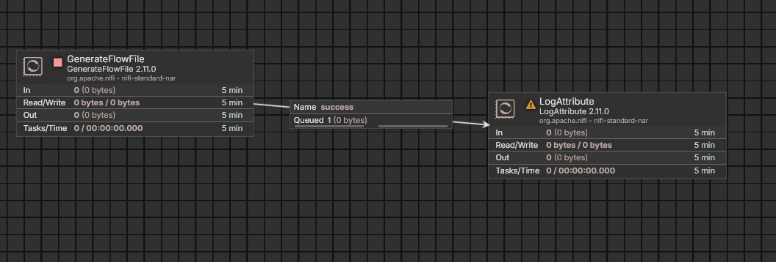
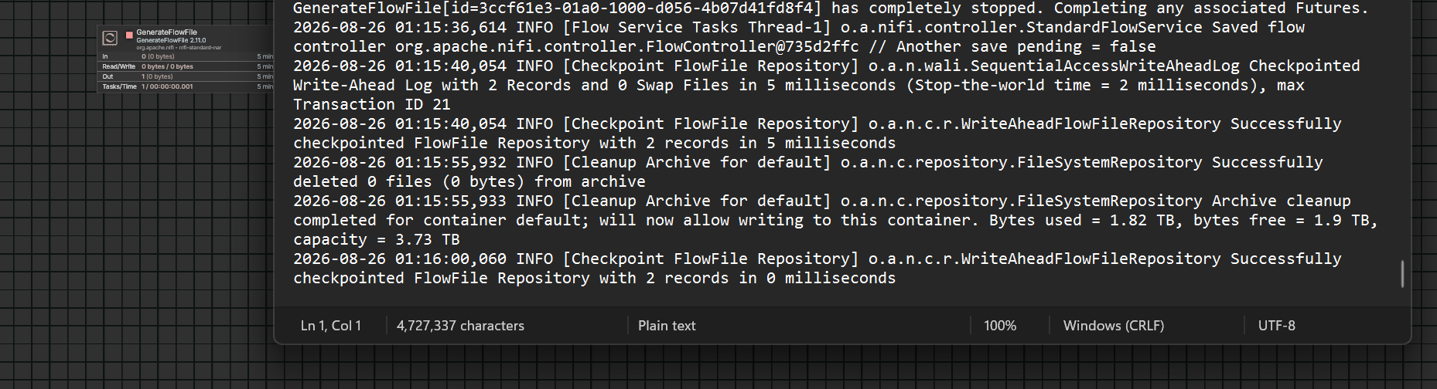

Exercise 2: File Copy Pipeline
Goal: Learn basic ingestion/egress processors and directory permissions.
Processors used: GetFile, PutFile

Steps
- On your machine, create two folders: ~/nifi-input and ~/nifi-output.
- Place a sample text file, e.g. sample.txt, inside ~/nifi-input.
- Add a GetFile processor. Configure:
  - Input Directory: /home/<you>/nifi-input
  - Keep Source File: true (so the file isn't deleted while you're testing)
- Add a PutFile processor. Configure:
  - Directory: /home/<you>/nifi-output
  - Conflict Resolution Strategy: replace
- Connect GetFile → PutFile on the success relationship.
- Start both processors.
- Check ~/nifi-output — your file should appear there within a few seconds.
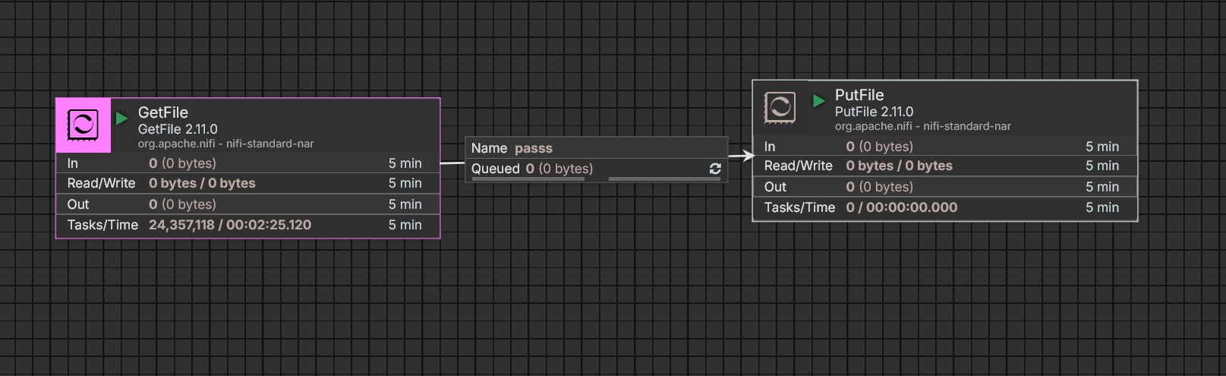

Exercise 3: Text Transformation
Goal: Practice configuring processor properties and regex-based replacement.
Processors used: GetFile, ReplaceText, PutFile

Steps
- Reuse the ~/nifi-input and ~/nifi-output folders (or create new ones for this exercise).
- Put a file in the input folder containing the word hello somewhere in its text.
- Add GetFile (same config as Exercise 2).
- Add ReplaceText. Configure:
  - Search Value: hello
  - Replacement Value: HELLO
  - Replacement Strategy: Regex Replace
- Add PutFile pointing to your output folder.
- Connect GetFile → ReplaceText (success), then ReplaceText → PutFile (success).
- Start all processors and confirm the output file now shows HELLO instead of hello.
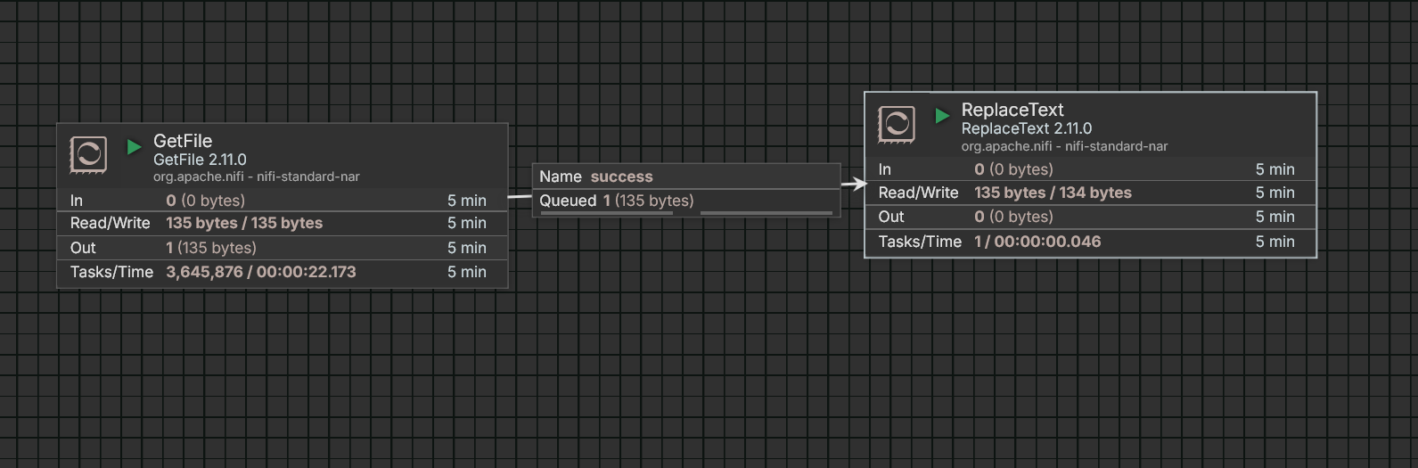

Exercise 4: CSV to JSON
Goal: Introduce Record-based processors and schema handling.
Processors used: GetFile, ConvertRecord (with CSVReader and JSONRecordSetWriter), PutFile

Steps
- Create a sample CSV file, people.csv, in your input folder:
name,age,cityAsha,29,MumbaiRahul,34,Pune

- Add GetFile pointing to your input folder.
- Add ConvertRecord. Before configuring it, you need two Controller Services:
  - Click the arrow icon next to Record Reader → Create New Service → choose CSVReader → Create.
  - Click the arrow icon next to Record Writer → Create New Service → choose JSONRecordSetWriter → Create.
- Go to the Controller Services tab (gear icon at bottom-left of canvas, or top-right menu → Controller Services). Find CSVReader and JSONRecordSetWriter.
- Configure CSVReader: set Schema Access Strategy to Use String Fields From Header (this auto-detects columns from the CSV header row).
- Configure JSONRecordSetWriter: leave defaults, but ensure Schema Write Strategy doesn't conflict — default settings work fine for this exercise.
- Enable (start) both controller services using the lightning bolt icon next to each.
- Back on ConvertRecord, confirm Record Reader = CSVReader and Record Writer = JSONRecordSetWriter.
- Add PutFile for your output folder.
- Connect GetFile → ConvertRecord (success) → PutFile (success).
- Start everything and check the output — it should be a JSON array of your CSV rows.
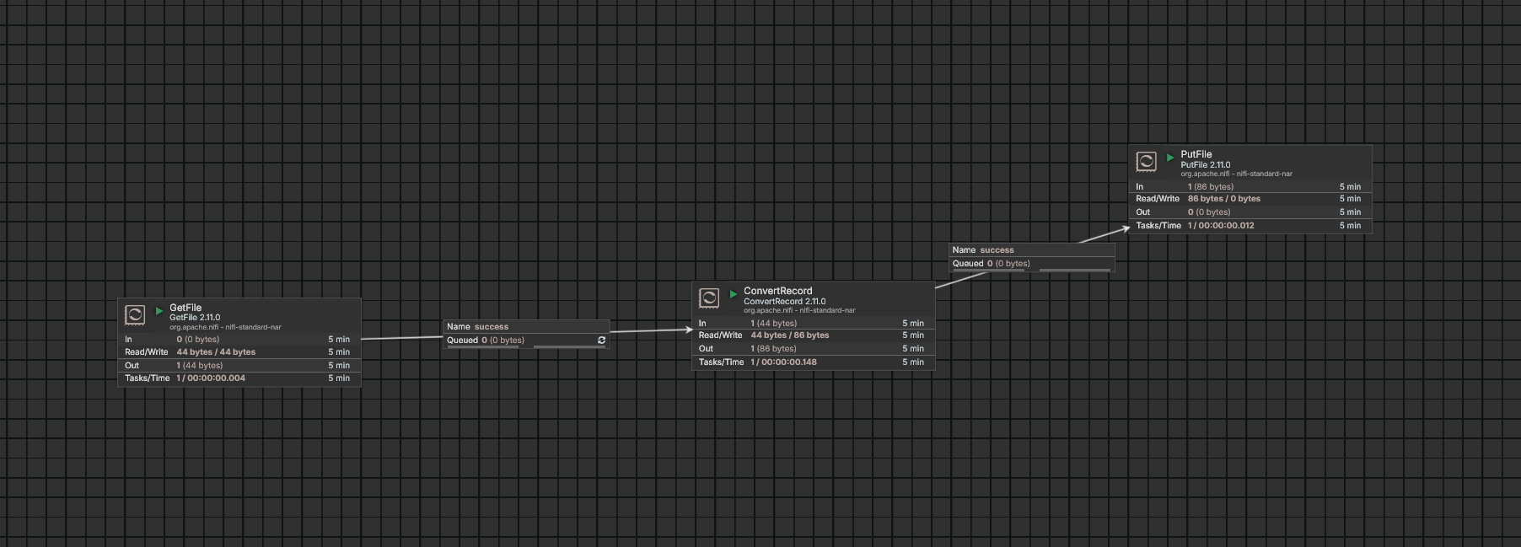

Exercise 5: Routing on Content
Goal: Learn conditional branching and NiFi relationships.
Processors used: GetFile, RouteOnContent, two PutFile processors

Steps
- Prepare two sample files in your input folder — one containing the word ERROR, one that doesn't.
- Add GetFile pointing to the input folder.
- Add RouteOnContent. Configure:
  - Match Requirement: content must contain match
  - Add a new dynamic property (click + on Properties tab): name it hasError, value: ERROR
- Add two PutFile processors: one pointing to ~/nifi-output/errors, the other to ~/nifi-output/clean. Create these folders first.
- Connect GetFile → RouteOnContent (success).
- Connect RouteOnContent → first PutFile on the hasError relationship.
- Connect RouteOnContent → second PutFile on the unmatched relationship.
- Start all processors and drop both sample files in the input folder.
- Confirm the error file lands in errors/ and the clean file lands in clean/.
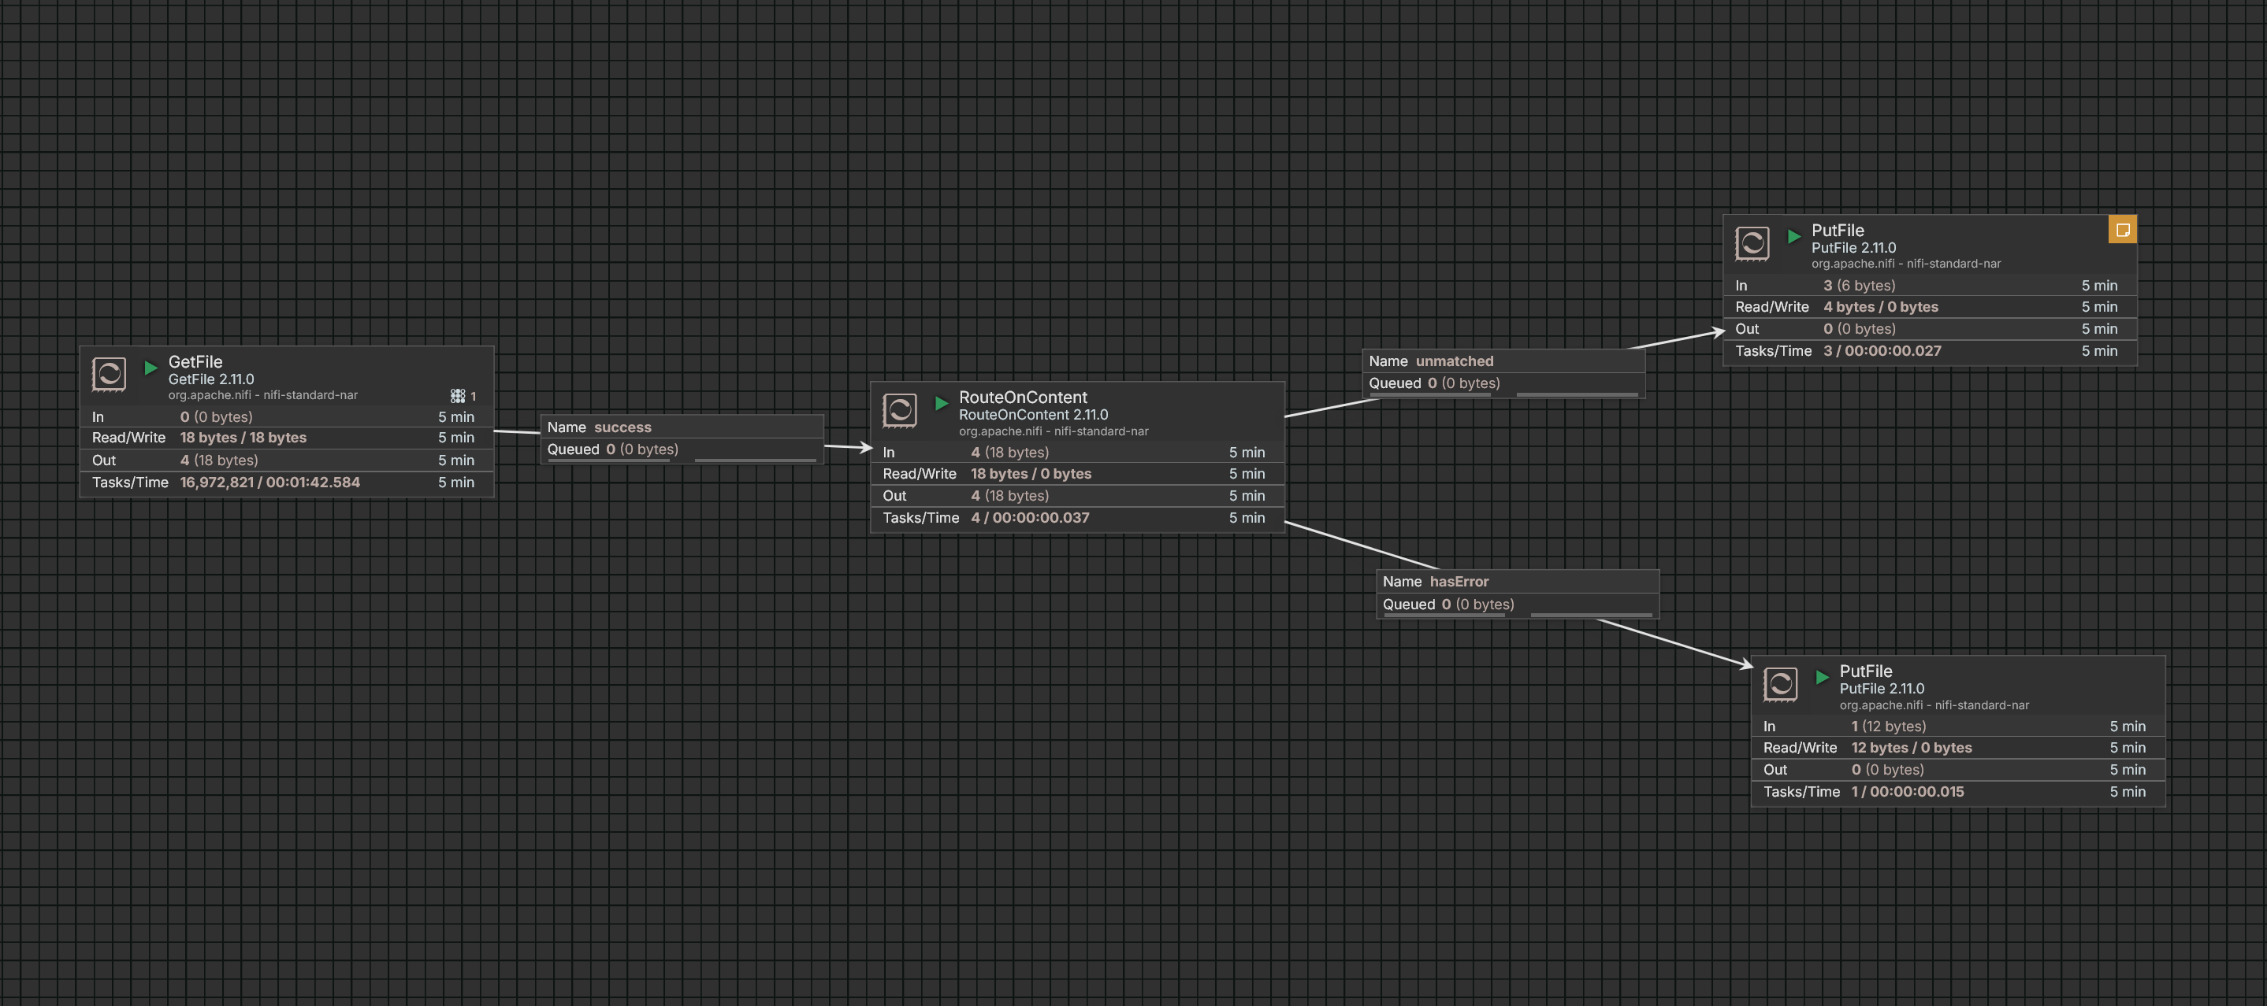

Exercise 6: Attribute Extraction
Goal: Understand the difference between FlowFile content and attributes.
Processors used: GetFile, UpdateAttribute, LogAttribute

Steps
- Add GetFile pointing to your input folder (reuse sample.txt from earlier).
- Add UpdateAttribute. Add a new dynamic property:
  - Name: source.folder
  - Value: nifi-input
- Add another dynamic property using NiFi Expression Language:
  - Name: file.sizeInKB
  - Value: ${fileSize:divide(1024)}
- Add LogAttribute. Configure Log Level to info and Attributes to Log to blank (logs all attributes).
- Connect GetFile → UpdateAttribute (success) → LogAttribute (success).
- Start everything and check nifi-app.log — you should see source.folder and file.sizeInKB listed among the FlowFile's attributes, while the content of the file remains untouched.

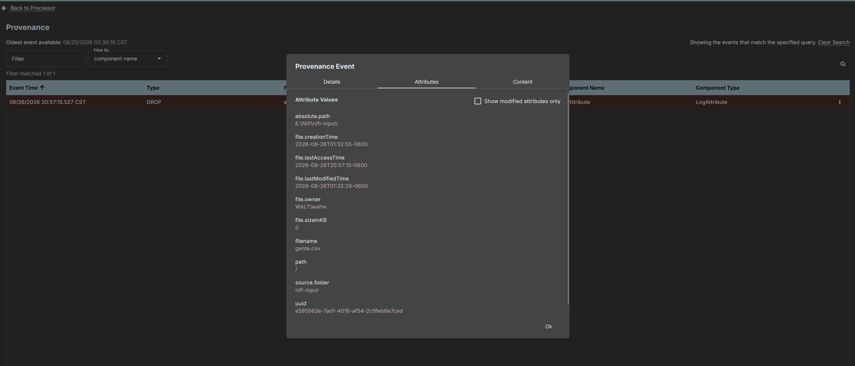\
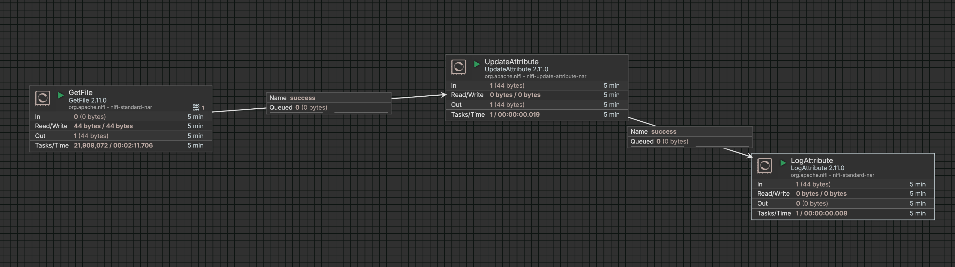

Exercise 7: Error Handling
Goal: Learn NiFi's expectation that every relationship must be handled.
Processors used: Reuse Exercise 2 or 4's flow, plus LogAttribute for failures

Steps
- Open your flow from Exercise 4 (CSV to JSON).
- Click on the ConvertRecord processor — notice the failure relationship is likely unset (shown with a warning icon if left unhandled).
- Add a LogAttribute processor and configure Log Level to error.
- Connect ConvertRecord → this new LogAttribute on the failure relationship.
- Start it. To test, drop a malformed CSV file (e.g., mismatched columns or corrupted text) into your input folder.
- Confirm the failure path logs the issue instead of leaving FlowFiles stuck in a queue with no downstream connection.
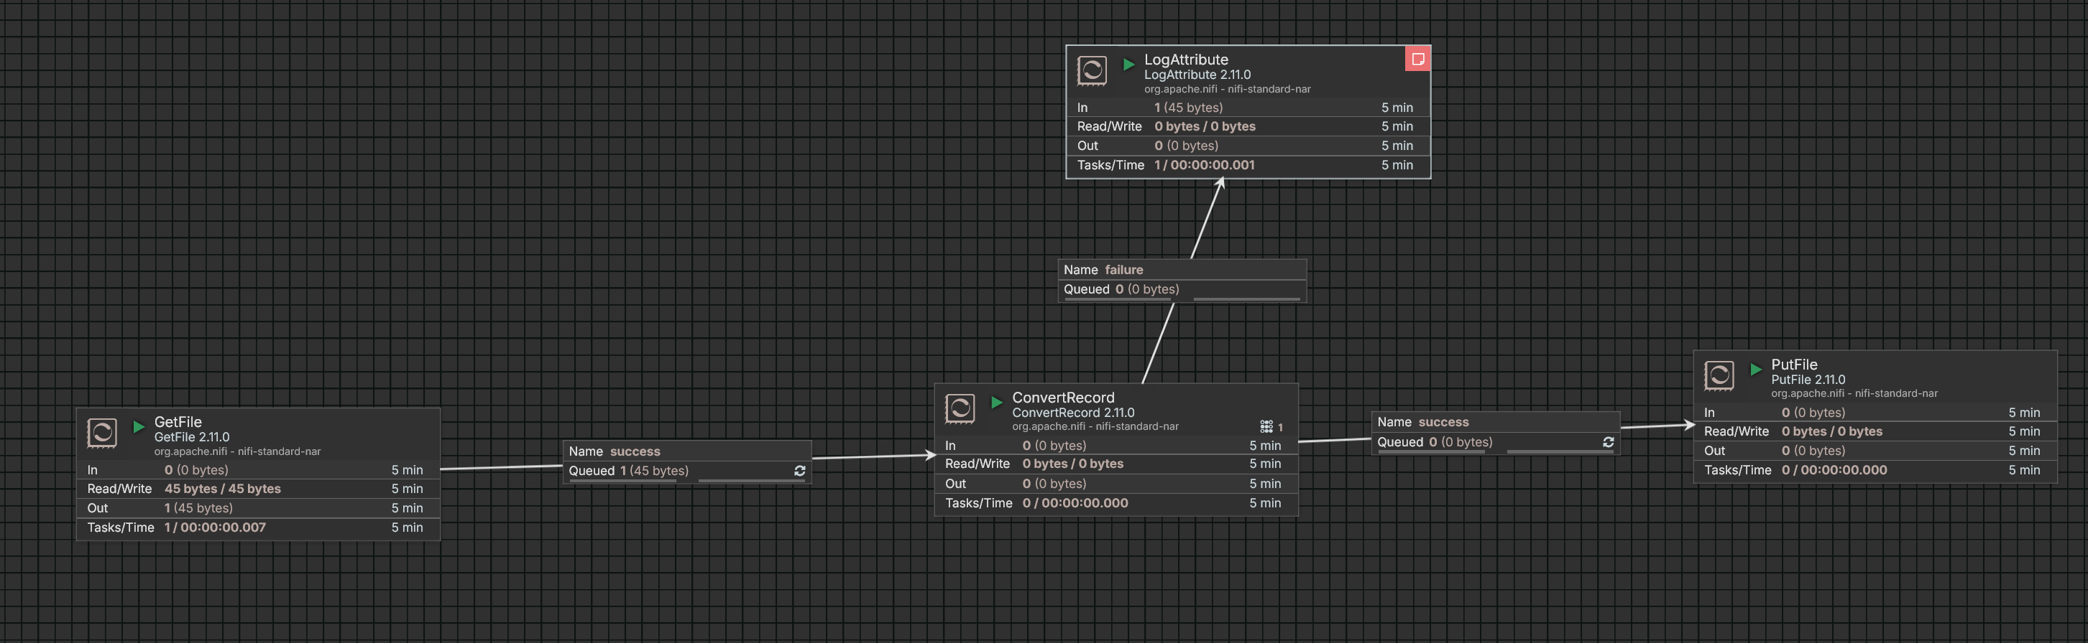

Exercise 8: Scheduling Practice
Goal: Understand processor scheduling strategies.
Processors used: Reuse Exercise 4's GetFile

Steps
- Right-click GetFile → Configure → Scheduling tab.
- Change Scheduling Strategy from Timer driven to CRON driven.
- Set the CRON expression to run every minute: 0 * * * * ?
- Apply and start the processor. Watch the Data Provenance or output folder to confirm it runs on schedule.
- Switch back to Timer driven and set Run Schedule to 5 sec. Compare behavior.
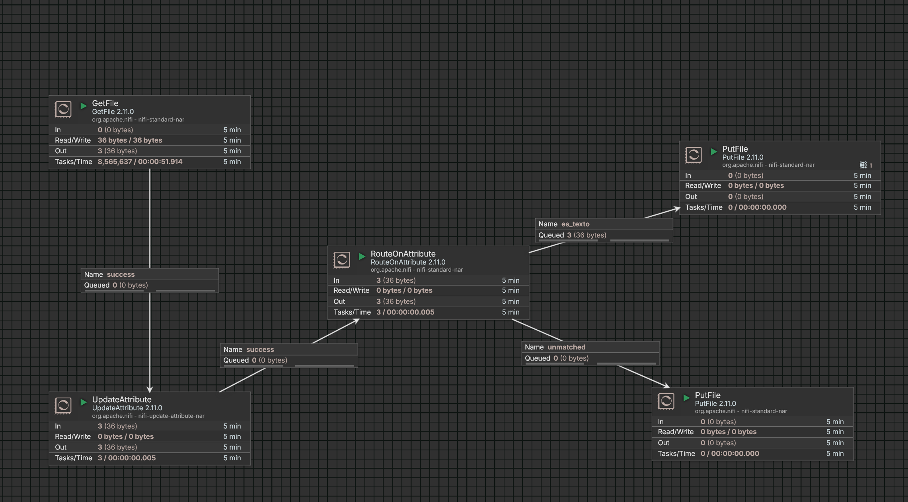

Exercise 9: Simple REST Pull
Goal: Introduce HTTP-based ingestion.
Processors used: InvokeHTTP, LogAttribute (or PutFile)

Steps
- Add InvokeHTTP. Configure:
  - HTTP Method: GET
  - Remote URL: https://api.agify.io?name=michael
- Leave SSL Context Service blank (not required for this public HTTPS API in most NiFi versions — if you hit SSL errors, create a StandardSSLContextService with defaults and enable it).
- Add LogAttribute and connect InvokeHTTP → LogAttribute on the Response relationship.
- You'll also need to handle other relationships (Failure, No Retry, Retry) — connect them to a second LogAttribute or terminate them (right-click connection → configure as auto-terminated in the processor's Relationships tab).
- Start the flow and check the log for the JSON response (something like {"count":..., "name":"michael","age":...}).
Check yourself: Swap the URL for a different public API (e.g. https://api.coindesk.com/v1/bpi/currentprice.json) and confirm it still works.

Resulted in a file named 253548220415100 with all the contents merged
